## Overview

Pushing your code to GitHub is the first step to having a publicly accessible webpage. In this activity, you’ll learn how to clone a GitHub repository, upload your code to GitHub, and publish your static webpage on GitHub Pages.

## Instructions

### **Part 1: Create a Repository (Repo)**

1. Go to [GitHub](https://www.github.com), click on the **+** icon in the upper-right corner and select **New repository**.



1. Name your new repository My_First_Repo and select **Public**.
2. Click **Create repository**.

### **Part 2: Clone Your Repository (Repo)**

1. Open GitHub Desktop and log in using your GitHub account credentials.

Download GitHub Desktop [here](https://desktop.github.com/) if you haven’t already done so.

1. Under the dropdown menu, select **File > Clone Repository**.

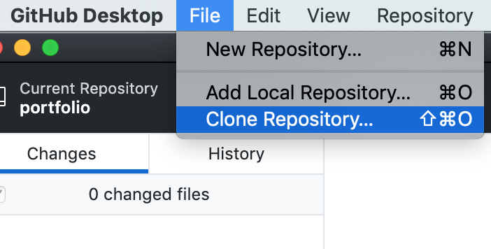

1. You should see this screen:

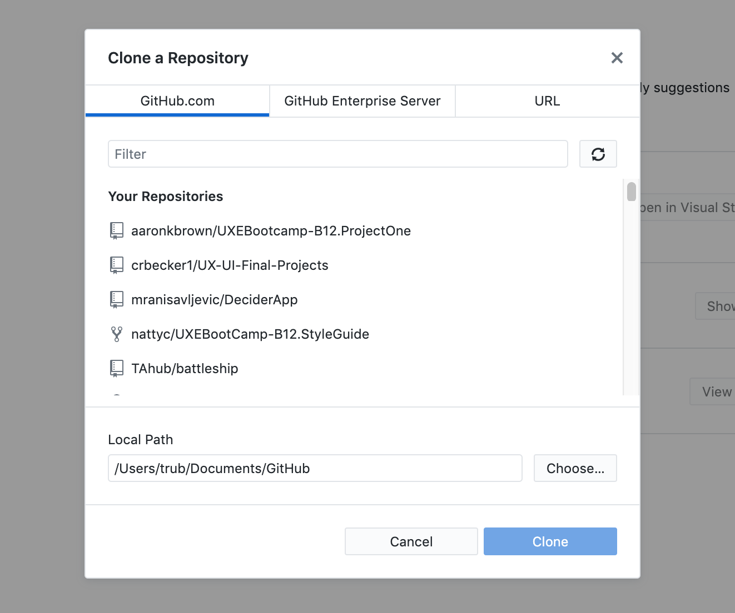

1. Press the refresh button so that GitHub can load the new repository you created.

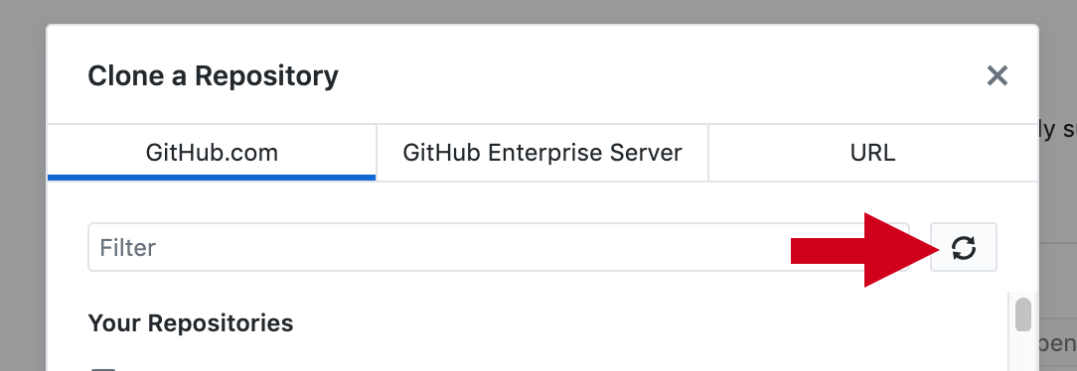



1. Choose a location on your computer to save a local copy of your repository. Make sure to choose a spot you will remember, then click **Clone**.

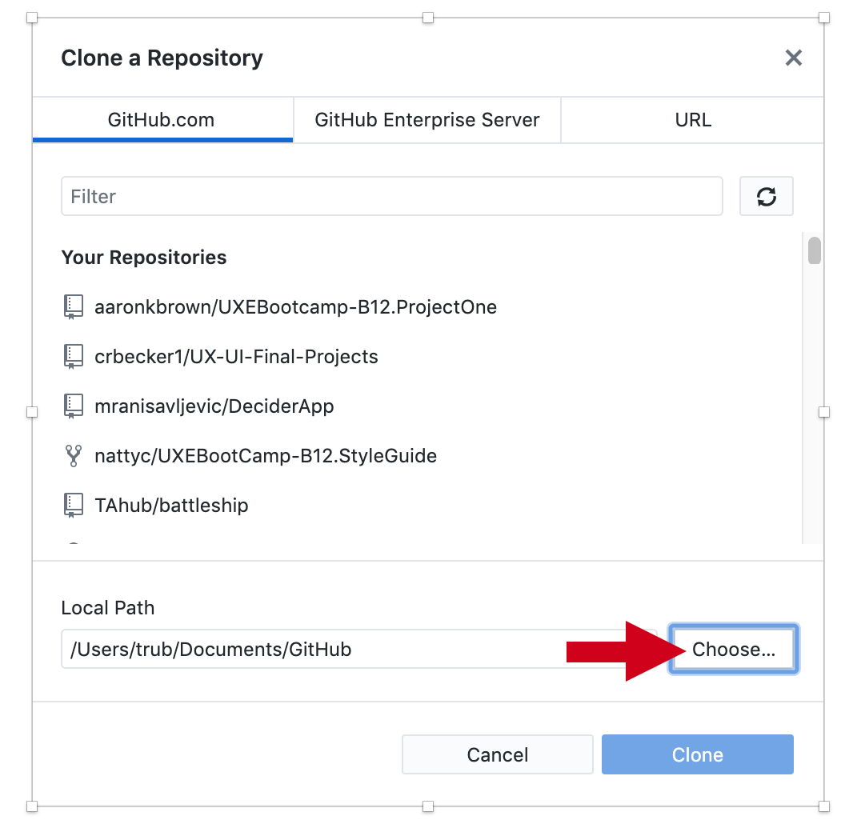

1. Now you need to add files to your new repository.

Your GitHub Desktop page should look like this. Select the button **Show in Finder.**

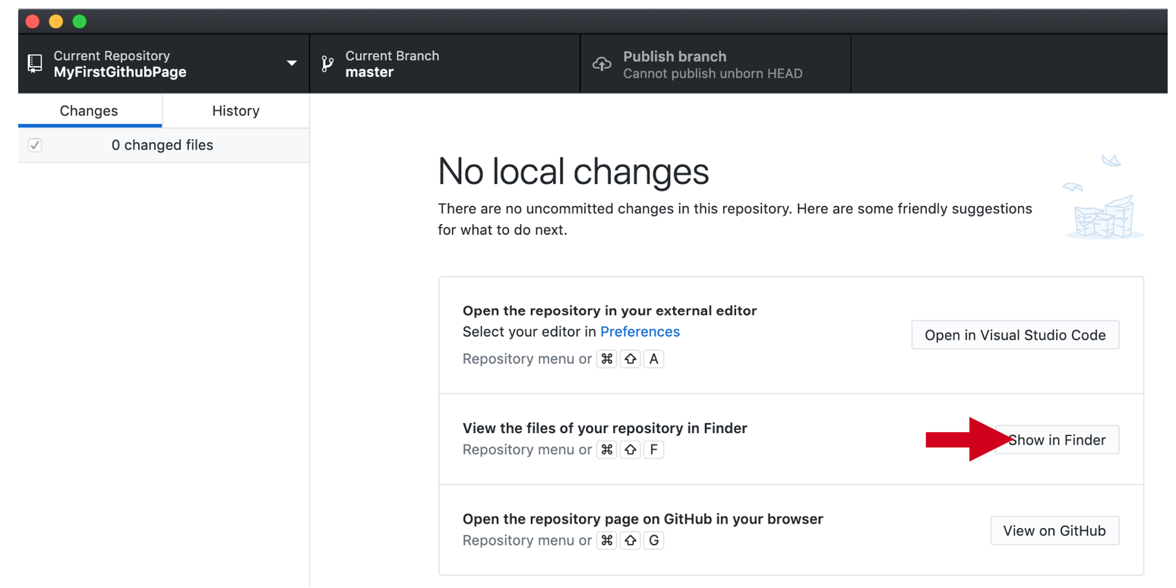

1. Move all the files and folders you created in the last activity into your repository’s folder.



1. Be sure that your HTML file is named index.html for GitHub to load your page correctly when you host it in the next activity.

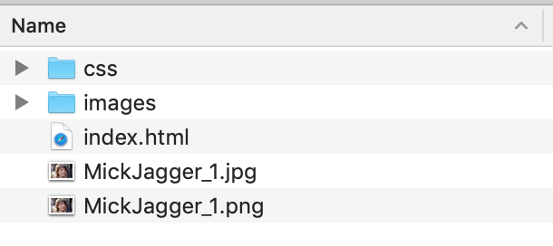

1. Go back to GitHub Desktop. It will now recognize that you have changed the files in your repository folder and will start tracking those changes.

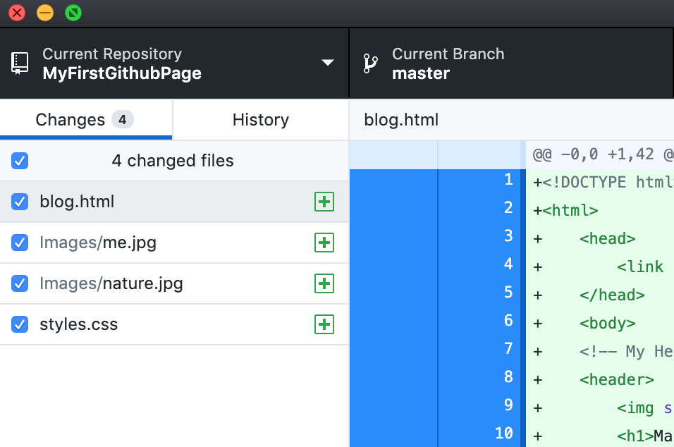

1. In GitHub Desktop, enter a high-level summary of changes in the **Summary** field.
   * The **Description** field is optional but can be used to add further detail.
   * After you have entered a summary, click **Commit to master.**

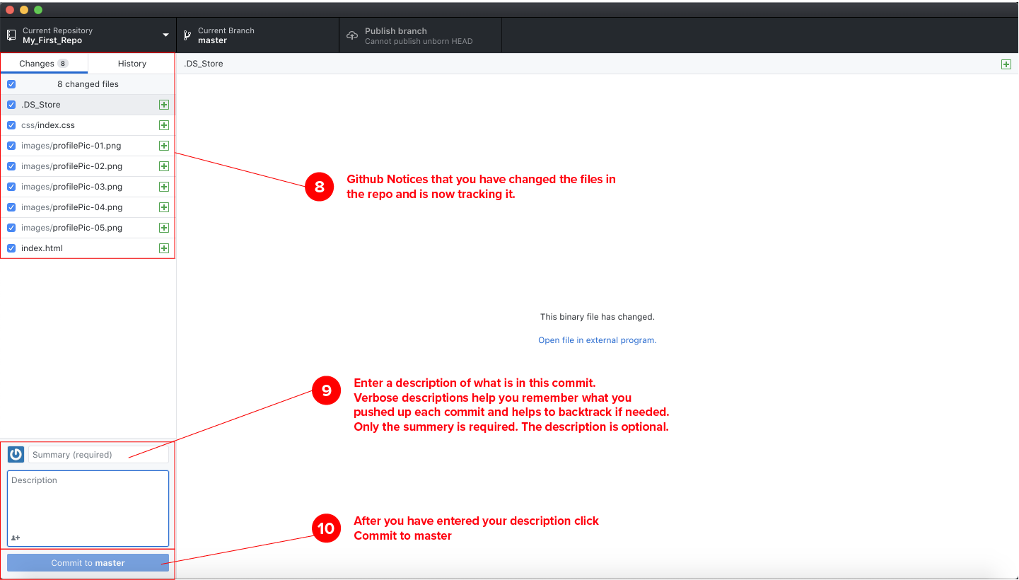

1. Finally, click **Publish branch** in GitHub Desktop to upload your changed files to GitHub.

### **Part 3: Take Your Page Live**

1. Go back to GitHub. In the top right corner of the navigation bar, select the drop-down menu from your profile icon. Select **Your profile**.

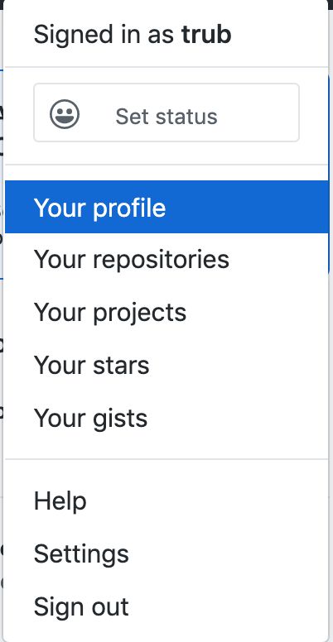

1. On your profile, select the **Repositories** tab.

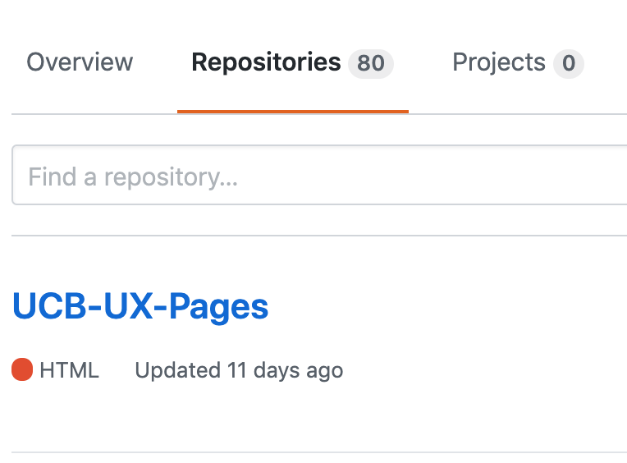

1. Select the repository you created. On the repository page, find the **Settings** tab and click it.  
    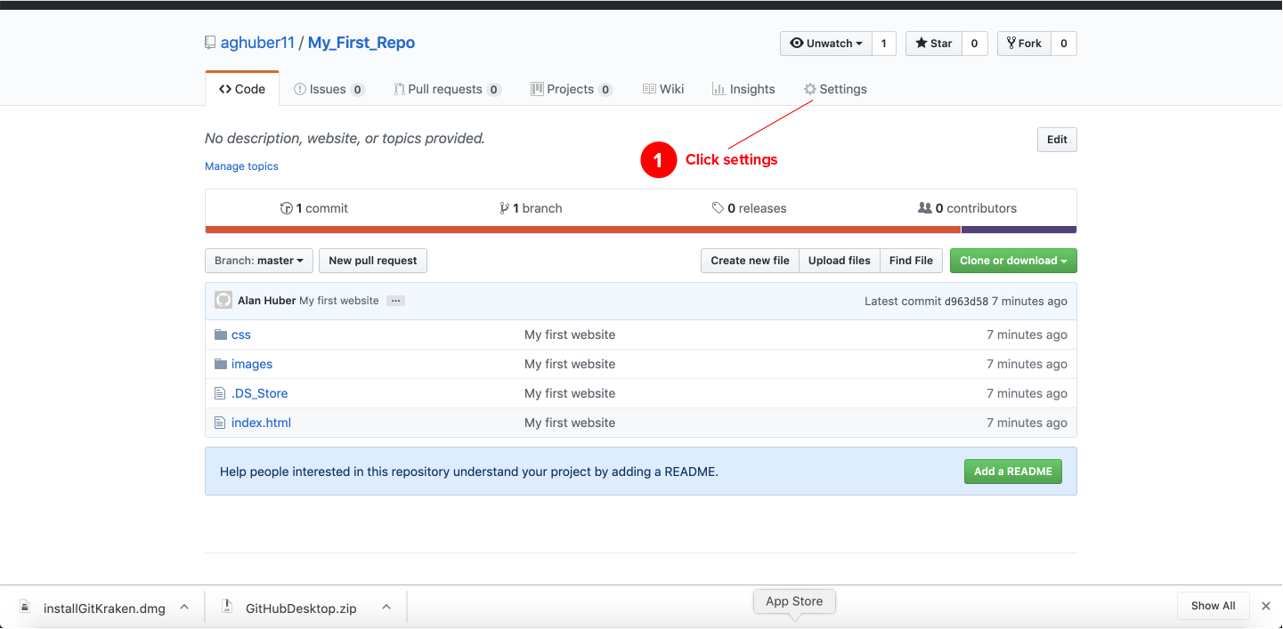
2. In the **Settings** tab, scroll down to the GitHub Pages section. Click the dropdown under **Source** and choose master branch.
   * This will tell GitHub to make your page live on the web.

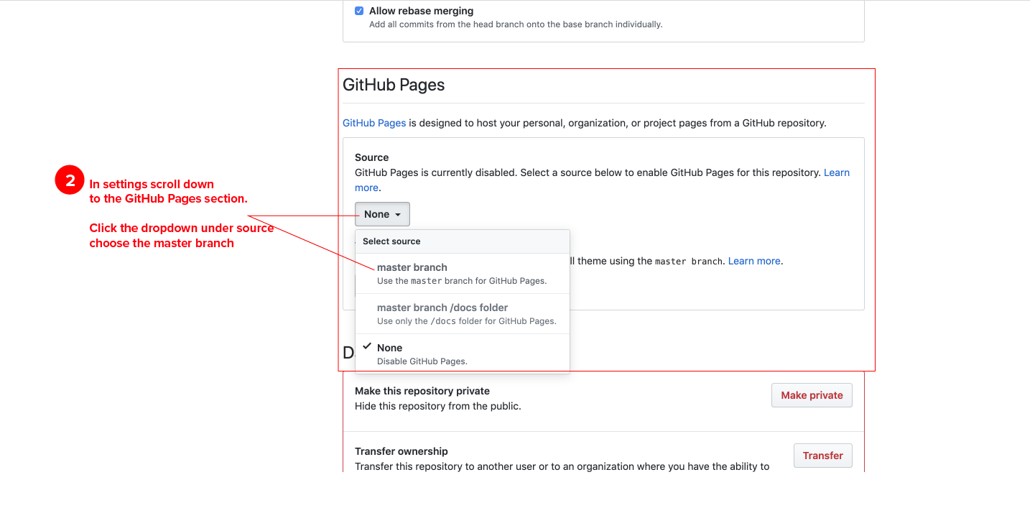

1. The URL for your live webpage will appear above the **Source** section.
   * *Note: GitHub Pages can take up to 15 minutes to refresh with any changes.*

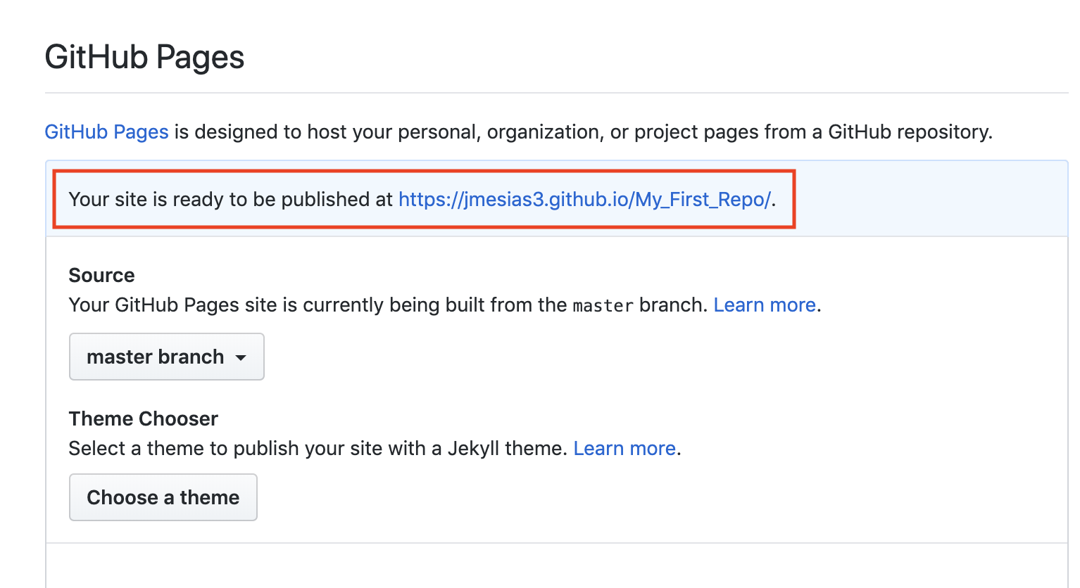

* + When your site is published, it will look green.

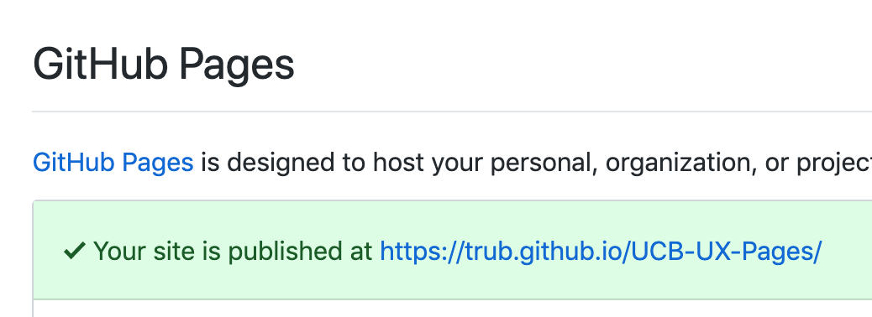

Congratulations! Your first webpage is now live.